Part Number: PT944-24150

Kit Contents
Item # | Quantity Reqd. | Description
1 | 2 | Inner LED Scuff
2 | 2 | Outer Scuff
3 | 1 | Hardware Bag
Hardware Bag Contents
Item # | Quantity Reqd. | Description
1 | 15 | 20 cm Wire Ties
2 | 4 | 3M Scotchloks
3 | 6 | Foam Tape
Additional Items Required For Installation
Item # | Quantity Reqd. | Description
1
2
3
Conflicts
Recommended Tools
Personal & Vehicle Protection | Notes
Safety Glasses
Safety Gloves | Optional
Vehicle Protection | Blankets, Parts Boxes
Special Tools | Notes
Installation Tools | Notes
Phillips Screwdriver
Nylon Panel Removal Tool | e.g. Panel Pry Tool #1
Metal 90-Degree Pick
Side Cutters
Pliers
Needle Nose Pliers
Ratchet & Socket | 10mm
Torque Wrench | 5.4 N-m (48 in-lbs)
Special Chemicals | Notes
Cleaner | VDC Approved Cleaner
General Applicability
Recommended Sequence of Application
Item # | Accessory
1
2
3
*Mandatory
Vehicle Service Parts (may be required for reassembly)
Item # | Quantity Reqd. | Description
1
2
3
Legend
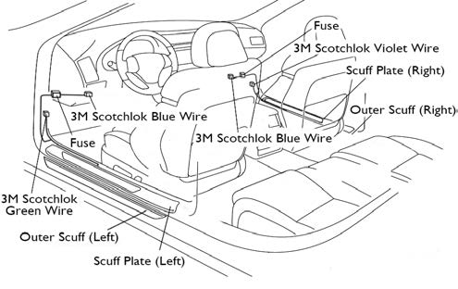
STOP: Damage to the vehicle may occur. Do not proceed until process has been complied with.
OPERATOR SAFETY: Use caution to avoid risk of injury.
CAUTION: A process that must be carefully observed in order to reduce the risk of damage to the accessory/vehicle and to ensure a quality installation.
TOOLS & EQUIPMENT: Used in Figures calls out the specific tools and equipment recommended for this process.
REVISION MARK: This mark highlights a change in installation with respect to previous issue.
SAFETY TORQUE: This mark indicates that torque is related to safety.

Care must be taken when installing this accessory to ensure damage does not occur to the vehicle. The installation of this accessory should follow approved guidelines to ensure a quality installation.

These guidelines can be found in the "Accessory Installation Practices" document.

This document covers such items as:-
- Vehicle Protection (use of covers and blankets, cleaning chemicals, etc.).
- Safety (eye protection, rechecking torque procedure, etc.).
- Vehicle Disassembly/Reassembly (panel removal, part storage, etc.).
- Electrical Component Disassembly/Reassembly (battery disconnection, connector removal, etc.).

Please see your Lexus dealer for a copy of this document.

Disassemble the Vehicle.
  - Set the parking brake.
  - Lower the windows and move the seats to the full rearmost position.
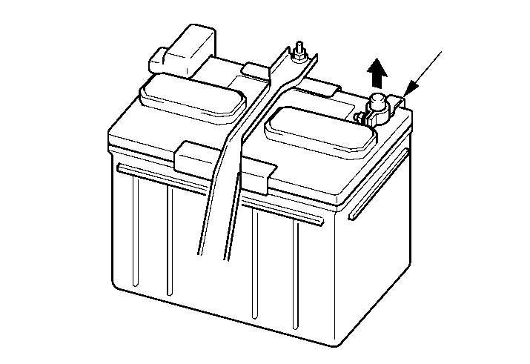
  - Remove the negative battery cable (Fig. 1-1).
Fig. 1-1
Negative battery terminal
10mm socket & ratchet
    - Protect the fender before starting.
    - Do not touch the positive terminal with any tool when removing the cable.

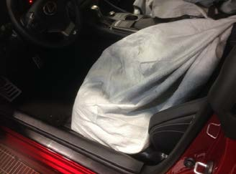
  - Cover the seat with a blanket (Fig. 1-2).
Fig. 1-2
  - Place masking tape on the front doorsill.

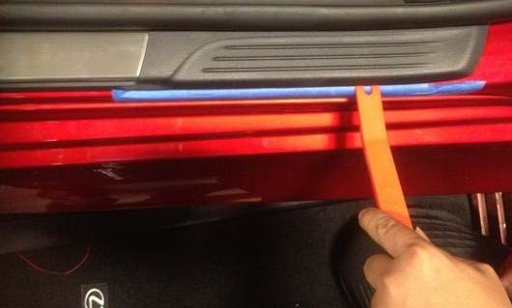
  - Use a nylon panel removal tool to disengage the four (4) clips and carefully lift the doorsill trim piece (Fig. 1-3).
Fig. 1-3
Nylon panel removal tool
  - Remove the masking tape and ensure no tape residue remains.

  - Remove the front driver side inner door sill trim.
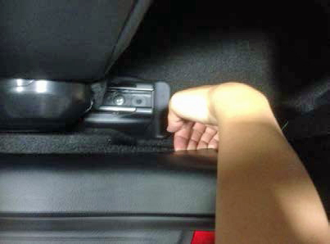
    - Hold the weather strip at the clip locations (Fig. 1-4).
Fig. 1-4
    - Dislodge the four (4) clips (Fig. 1-4).
CAUTION: Do not bend or break the bottom clips at either end of the sill trim.
  - Apply the parking brake to ease access to the kick panel.

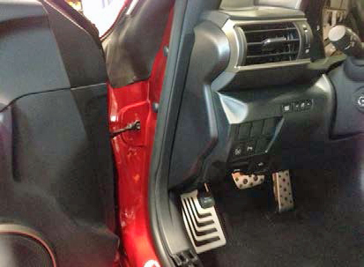
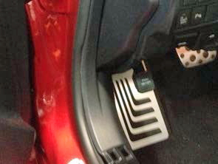
  - Pull to disengage the four (4) clips while holding the weather strip at the clip locations to remove the kick panel trim piece from the vehicle (Fig. 1-5 and Fig. 1-6). Rotate the part, with the finished surface going into the cabin, as it is removed to avoid breaking the clips.
Fig. 1-6
Fig. 1-5
NOTE: Do not remove the weather strip. Hold the weather strip at the clip area while pulling back the kick panel.

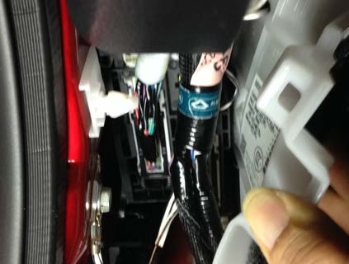
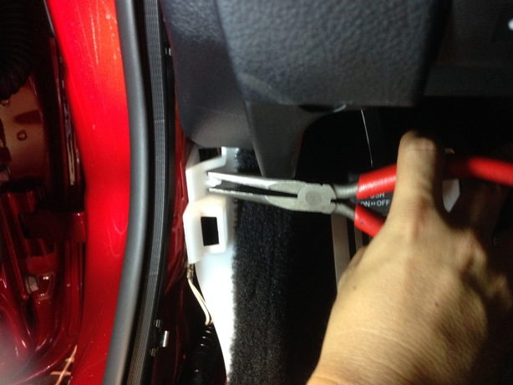
  - Squeeze the clip together with needle nose pliers and pull the kick panel towards the interior of the vehicle to disengage the carpeted kick panel (Fig. 1-7 and Fig. 1-8).
Fig. 1-8
Fig. 1-7
Needle nose pliers
  - Repeat Step 1(c) through Step 1(j) on the passenger side of the vehicle.

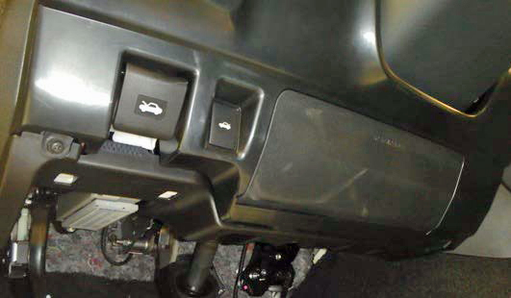
  - Remove the two screws and release the two clips from the driver side under dash trim panel (Fig. 1-9).
Fig. 1-9
Phillips screwdriver

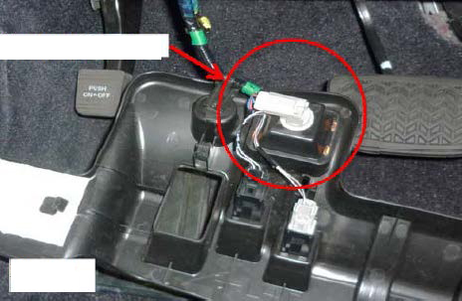
  - Pull down the driver side under dash trim panel to expose the foot light connector and disengage it (Fig. 1-10).
Fig. 1-10
Location of connectors
  - Place masking tape along the bottom edge of the passenger side knee panel.

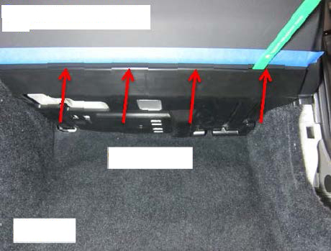
  - Use a nylon removal tool to release the 4 clips on the under dash trim panel (Fig. 1-11).
Fig. 1-11
Nylon panel removal tool
Clip locations

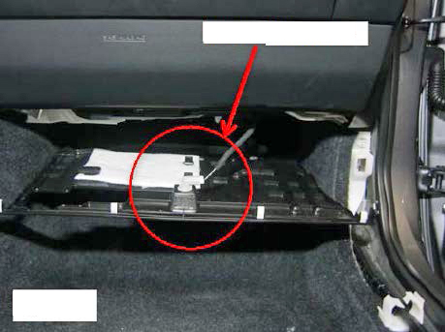
  - Lower the panel to expose the foot light connector. Disconnect it and remove the panel (Fig. 1-12).
Fig. 1-12
Location of connector
  - Remove the masking tape and ensure no tape residue remains.

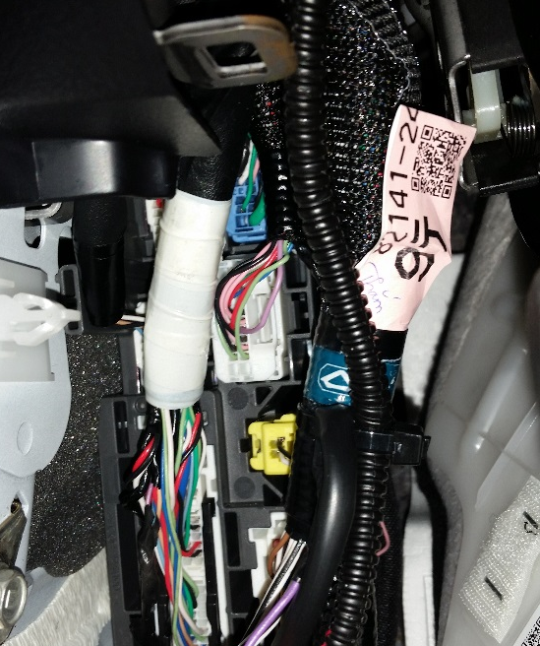

Install the Driver Side Door Sill.
  - Locate the 20 pin connector on the driver side kick panel connector block (Fig. 2-1).

Fig. 2-1

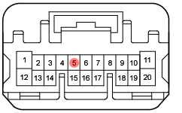
  - Disconnect the connector and locate the violet wire (CTY light [-], pin 5) (Fig. 2-2).

Fig. 2-2

Pliers
  - Connect the violet wire from the door sill to the violet wire on the vehicle connector with a Scotchlok (Fig. 2-3).
NOTE: Refer to Fig. 2-4 for instructions on proper Scotchlok installation.
  - Use pliers to push down the metal tab to splice the wires. Make sure both wires are spliced correctly (Fig. 2-3).
Fig. 2-3
  - Snap the plastic cover in place by hand.

Fig. 2-4 Proper application of Scotchlok

  - Cut a piece of foam tape in half and wrap it over the wire tap.
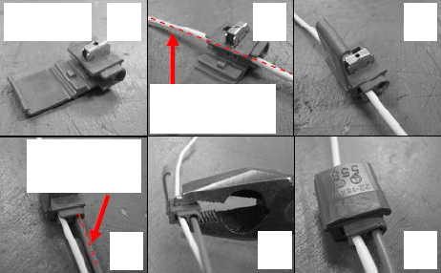
Fig. 2-4
b
c
d
e
f
a
Illuminated door sill wire
Foot well light connector wire
  - Reattach connector to the connector block (Fig. 2-5).
CAUTION: Make sure the connector lock engages securely.
Fig. 2-5

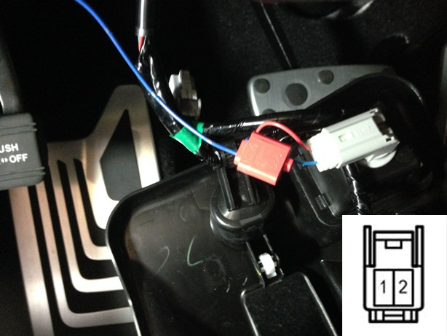
  - Locate the blue wire (B[+], pin 1) on the driver side foot lamp connector (Fig. 2-6).
Fig. 2-6
Pliers
  - Route the wire above the hood latch cable (see Fig. 2-10) and connect the blue wire from the door sill to the foot lamp with a Scotchlok (Fig. 2-8).

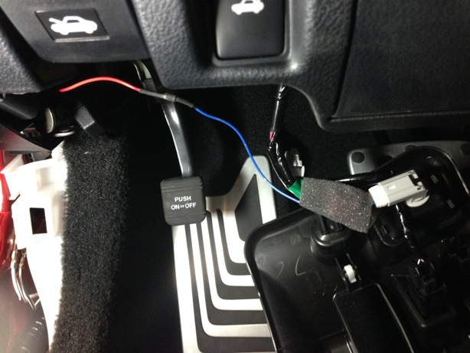
  - Apply foam tape over the fuse holder and Scotchlock (Fig. 2-7).
Fig. 2-7
NOTE: Do not cover the fuse holder cap.

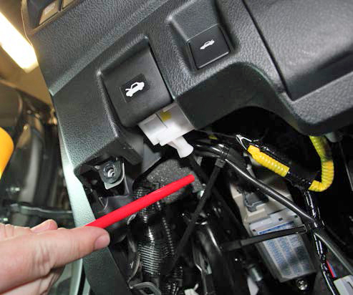
  - Apply two wire ties (Fig. 2-8).
Fig. 2-8
Side cutters
CAUTION: Make sure the wire is routed above the hood latch cable. Do not attach the wire to the hood latch cable.

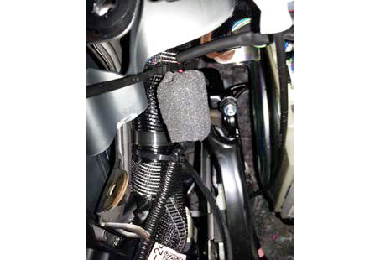
  - Route the door sill wire harness along the OE wire harness toward the bottom of the vehicle and secure the fuse with two wire ties (Fig. 2-9).
Fig. 2-9
Side cutters

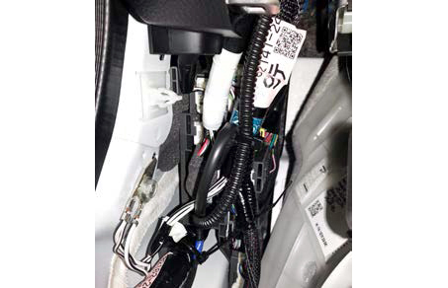
  - Route the door sill wire harness down along the OE wire harness and secure it with two wire ties (Fig. 2-10).
Fig. 2-10
Side cutters

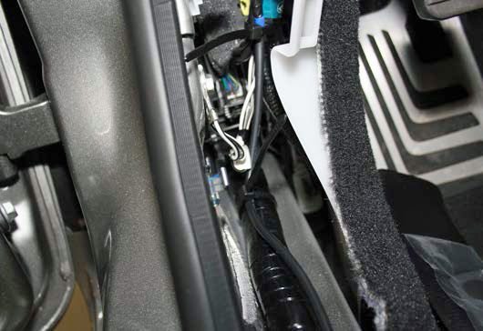
  - Route the door sill wire harness along the OE floor wire harness and secure it with one wire tie (Fig. 2-11).
Fig. 2-11
Side cutters

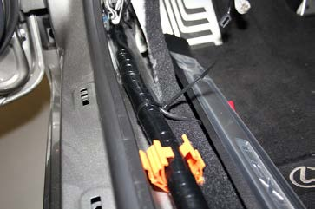
  - Route the door sill wire harness along the OE floor wire harness and secure it with one wire tie (Fig. 2-12).
Fig. 2-12
Side cutters

Install the Passenger Side Door Sill.
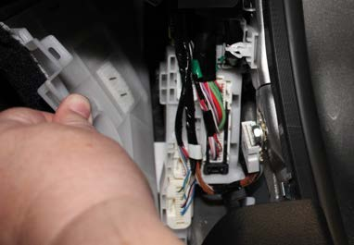
  - Locate the 64 pin connector behind the passenger side kick panel (Fig. 3-1).
Fig. 3-1

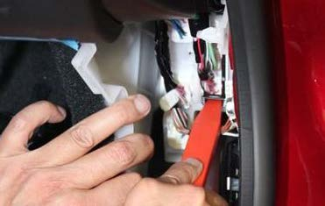
  - Push the locking tab up and pull the black lock mechanism out to remove the connector from the connector block (Fig. 3-2).
Fig. 3-2
Push locking tab up

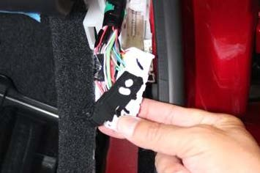
  - Remove the black lock mechanism (Fig. 3-3).
Fig. 3-3

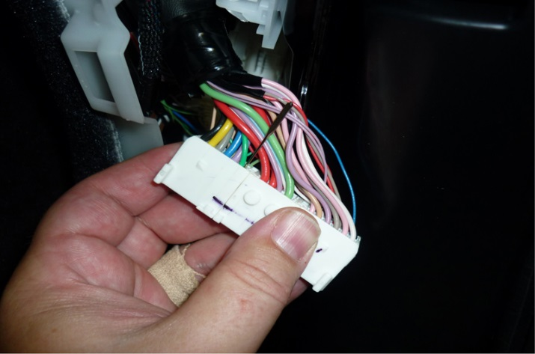
  - Locate the green wire (CTY light [-], pin 6) (Fig. 3-4).
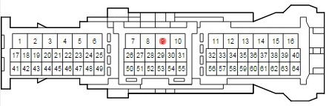

Fig. 3-4

  - Connect the green wire from the door sill to the green wire on the vehicle connector with a Scotchlok (Fig. 3-5).
Fig. 3-5
Pliers
  - Use pliers to push down the metal tab to splice the wires. Make sure both wires are spliced correctly.
  - Snap the plastic cover in place by hand.
  - Apply foam tape over the wire tap.

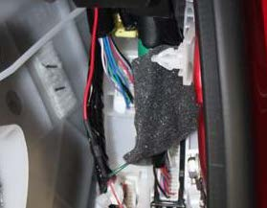
  - Reattach the black lock mechanism and reconnect it to the connector block (Fig. 3-6).
Fig. 3-6
CAUTION: Make sure the connector lock engages securely.

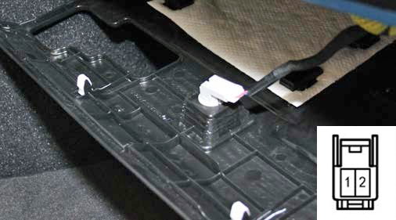
  - Locate the blue wire (B[+], pin 1) on the driver side foot lamp connector (Fig. 3-7).
Fig. 3-7

  - Connect the blue wire from the door sill to the foot lamp with a Scotchlok (Fig. 3-8).
Fig. 3-8
Pliers

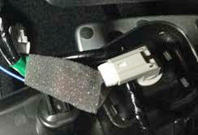
  - Apply foam tape over the Scotchlock (Fig. 3-9).
Fig. 3-9

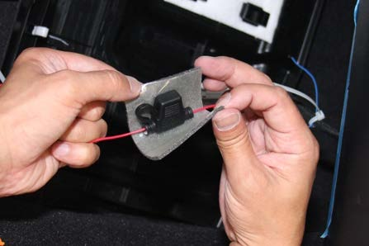
  - Apply foam tape over the fuse holder (Fig. 3-10).
Fig. 3-10

NOTE: Do not cover the fuse holder cap.

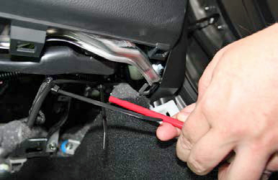
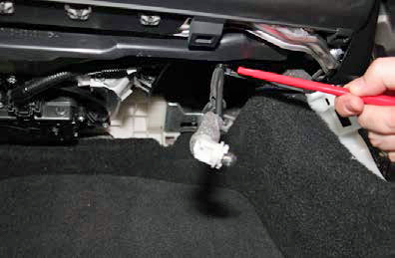
  - Tie the blue wire to the foot lamp wire harness with two wire ties (Fig. 3-11 and Fig. 3-12).
Fig. 3-12
Side cutters
Fig. 3-11
Side cutters

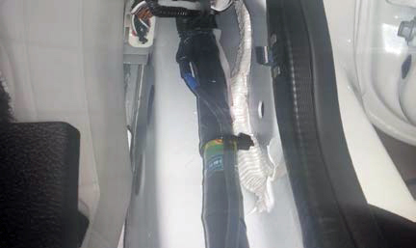
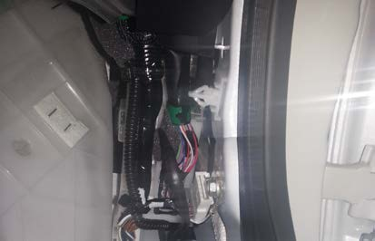
  - Route the door sill wire harness down along the OE wire harness and secure it with three wire ties (Fig. 3-13 and Fig. 3-14).
Fig. 3-14
Side cutters
Fig. 3-13
Side cutters

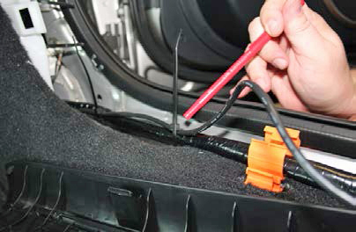
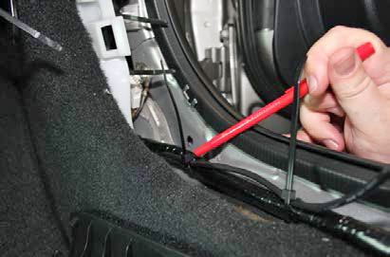
  - Route the door sill wire harness along the OE floor wire harness and secure it with two wire ties (Fig. 3-15 and Fig. 3-16).
Fig. 3-16
Side cutters
Fig. 3-15
Side cutters

Perform an In-Process Functional Test.
  - Temporarily reconnect the battery negative cable and install the DCC cut fuse if necessary.
NOTE: Make sure all doors and the trunk are closed before proceeding with the function test.
  - Confirm that the illuminated doorsills function properly.
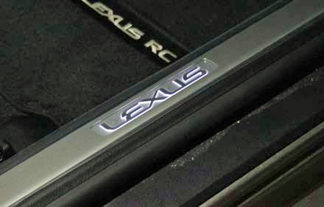
    - Door open – Front door sills are illuminated (Fig. 4-1).
Fig. 4-1
    - Door closed (or the door switch is pressed) – Front door sill illumination turns off.
  - Disconnect the battery negative cable and remove the DCC cut fuse if it was installed in Step 4(a).

Reassemble the Vehicle.
  - Reinstall the lower instrument panel covers. Make sure all hooks are snapped in and all screws are fastened.
  - Assemble the cowl panels. Make sure the clips are snapped in properly (Fig. 5-1).
Fig. 5-1

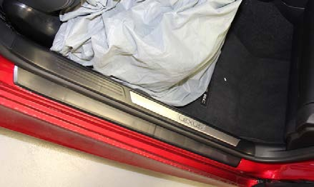
  - Install the door sills. Make sure the door sills are properly snapped down in place and that no lifting occurs or uneven gaps exist around the edges (Fig. 5-2).
Fig. 5-2
CAUTION: Ensure the clips at the left and right sides are engaged fully.
CAUTION: Ensure no wire pinch points exist between the sill and the body.

Reconnect the Battery.
  - Reconnect the battery negative cable.
Torque: 5.4 N-m (48 lbf-in)
  - Be careful not to touch the positive battery terminal with any tools.
  - Clean up and remove any trash.

Accessory Function Checks
Proper operation of the Illuminated Door Sills

Vehicle Function Checks
Dome light
Foot well lighting
Door courtesy lights
Parking brake light
Tail lights, brake lights, reverse lights, rear turn signals, hazard lights, license plate light
High beam dash light

Horn
Power door locks, power mirrors, power windows
12V/cigarette outlet
Dimmer switch
Radio reception
HVAC
Steering wheel controls
Trunk release
Smart key functions

Door open – Front door sills are illuminated.
Door closed – Front door sills are not illuminated

Dome light operates properly
Foot well lighting operates properly
Front door courtesy lights operate normally
Apply the parking brake and confirm the brake dash light comes on
All rear lights operate normally

Turn on the headlights, activate the high beams and verify the high beam dash light comes on
Horn operates properly
Power door locks, mirrors, and windows function normally
Outlet operates properly
Dimmer switch operates properly
Radio AM/FM reception operates normally
HVAC system operates properly
Steering wheel controls operate properly
Trunk release operates normally
Smart key functions operate normally

Vehicle Appearance Check
After accessory installation and removal of protective cover(s), perform a visual inspection.

Ensure no damage (including scuffs and scratches) was caused during the installation process.
(For PPO installations, refer to TMS Accessory Quality Shipping Standard.)

